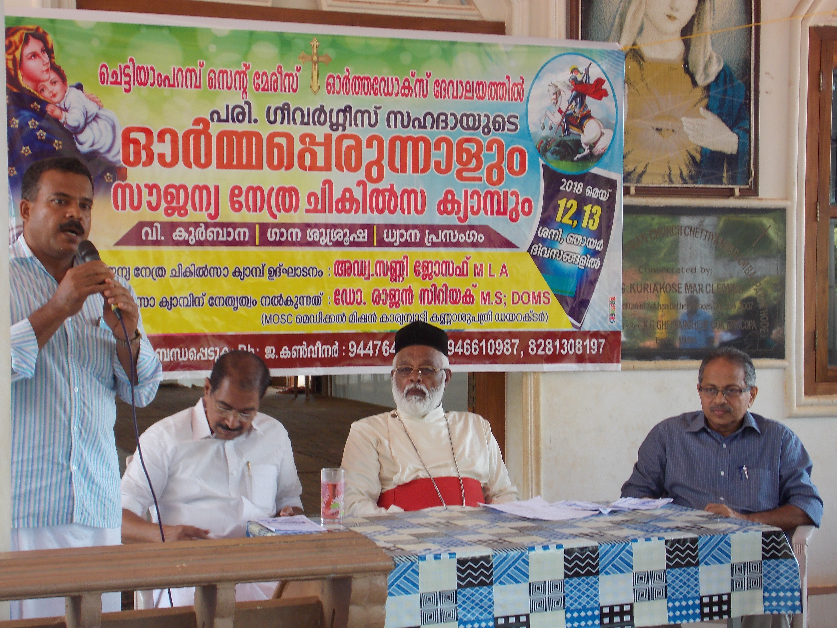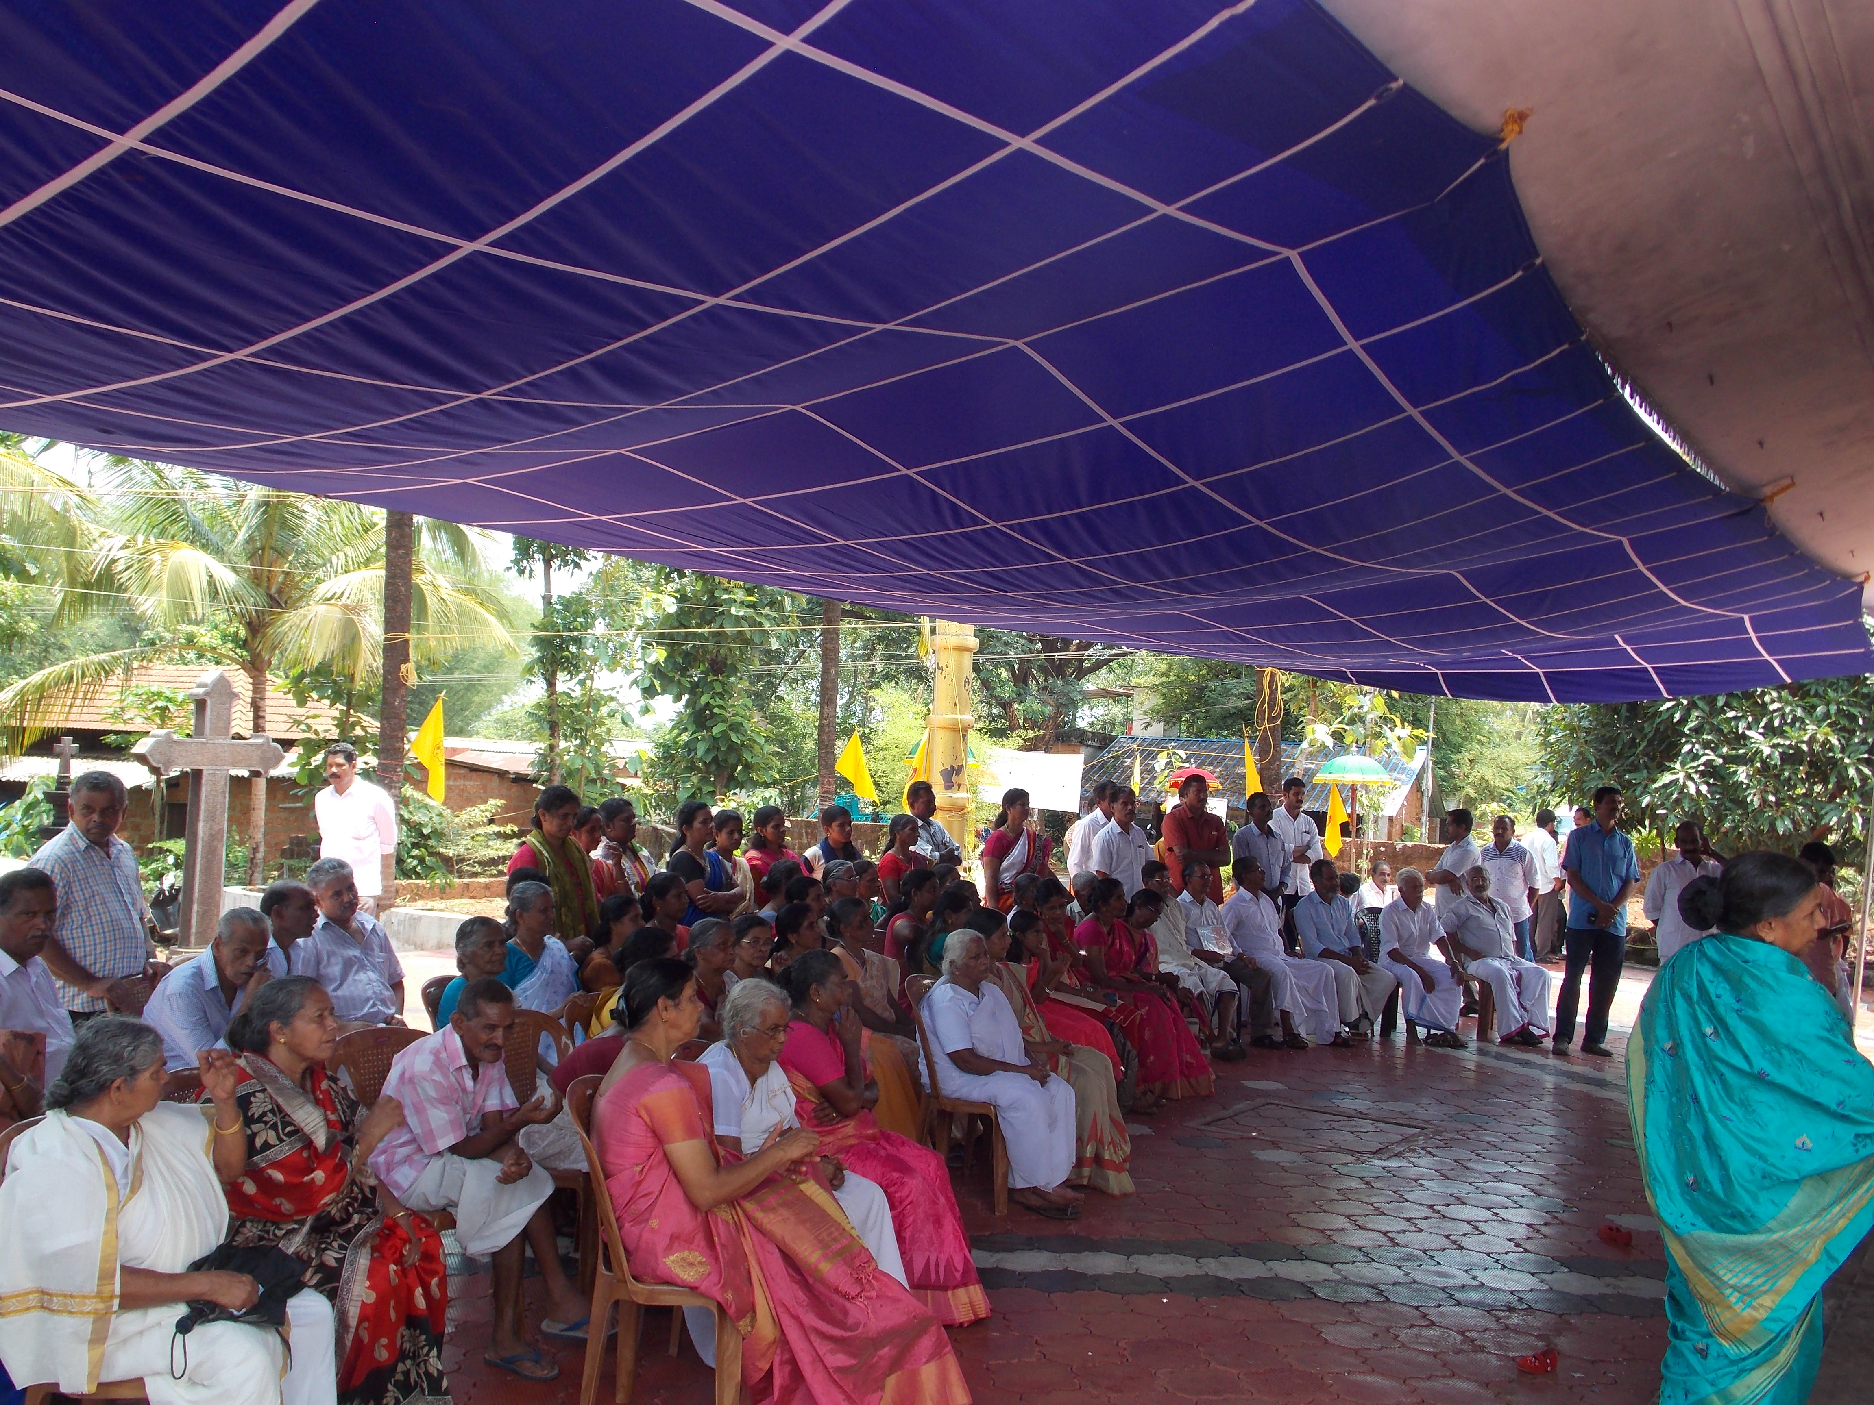

**Participants of Chettiyamparambu free eye camp**

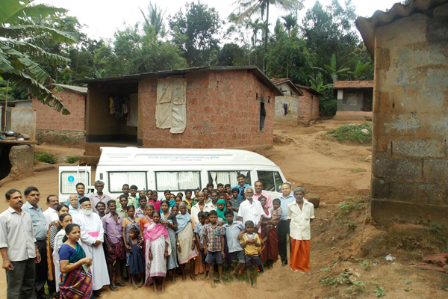

Free eye camp conducted in Chatigadha tribal colony, Wayanad

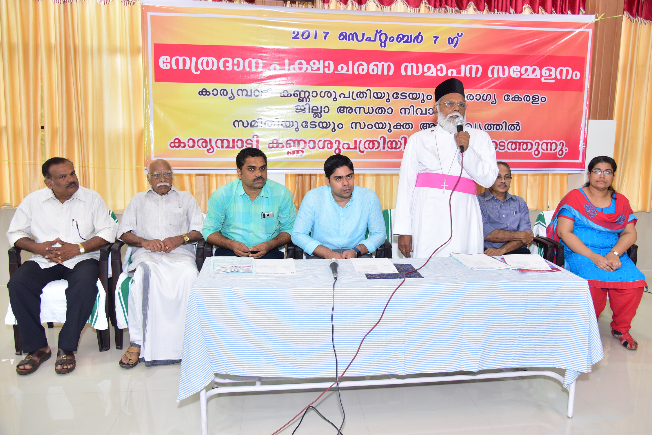

Nethrapakshacharana Samapana Sammelanam

in the Presence of Wayanad district Collector Mr.S.Suhas I.A.S.Welcome speech – Secretary

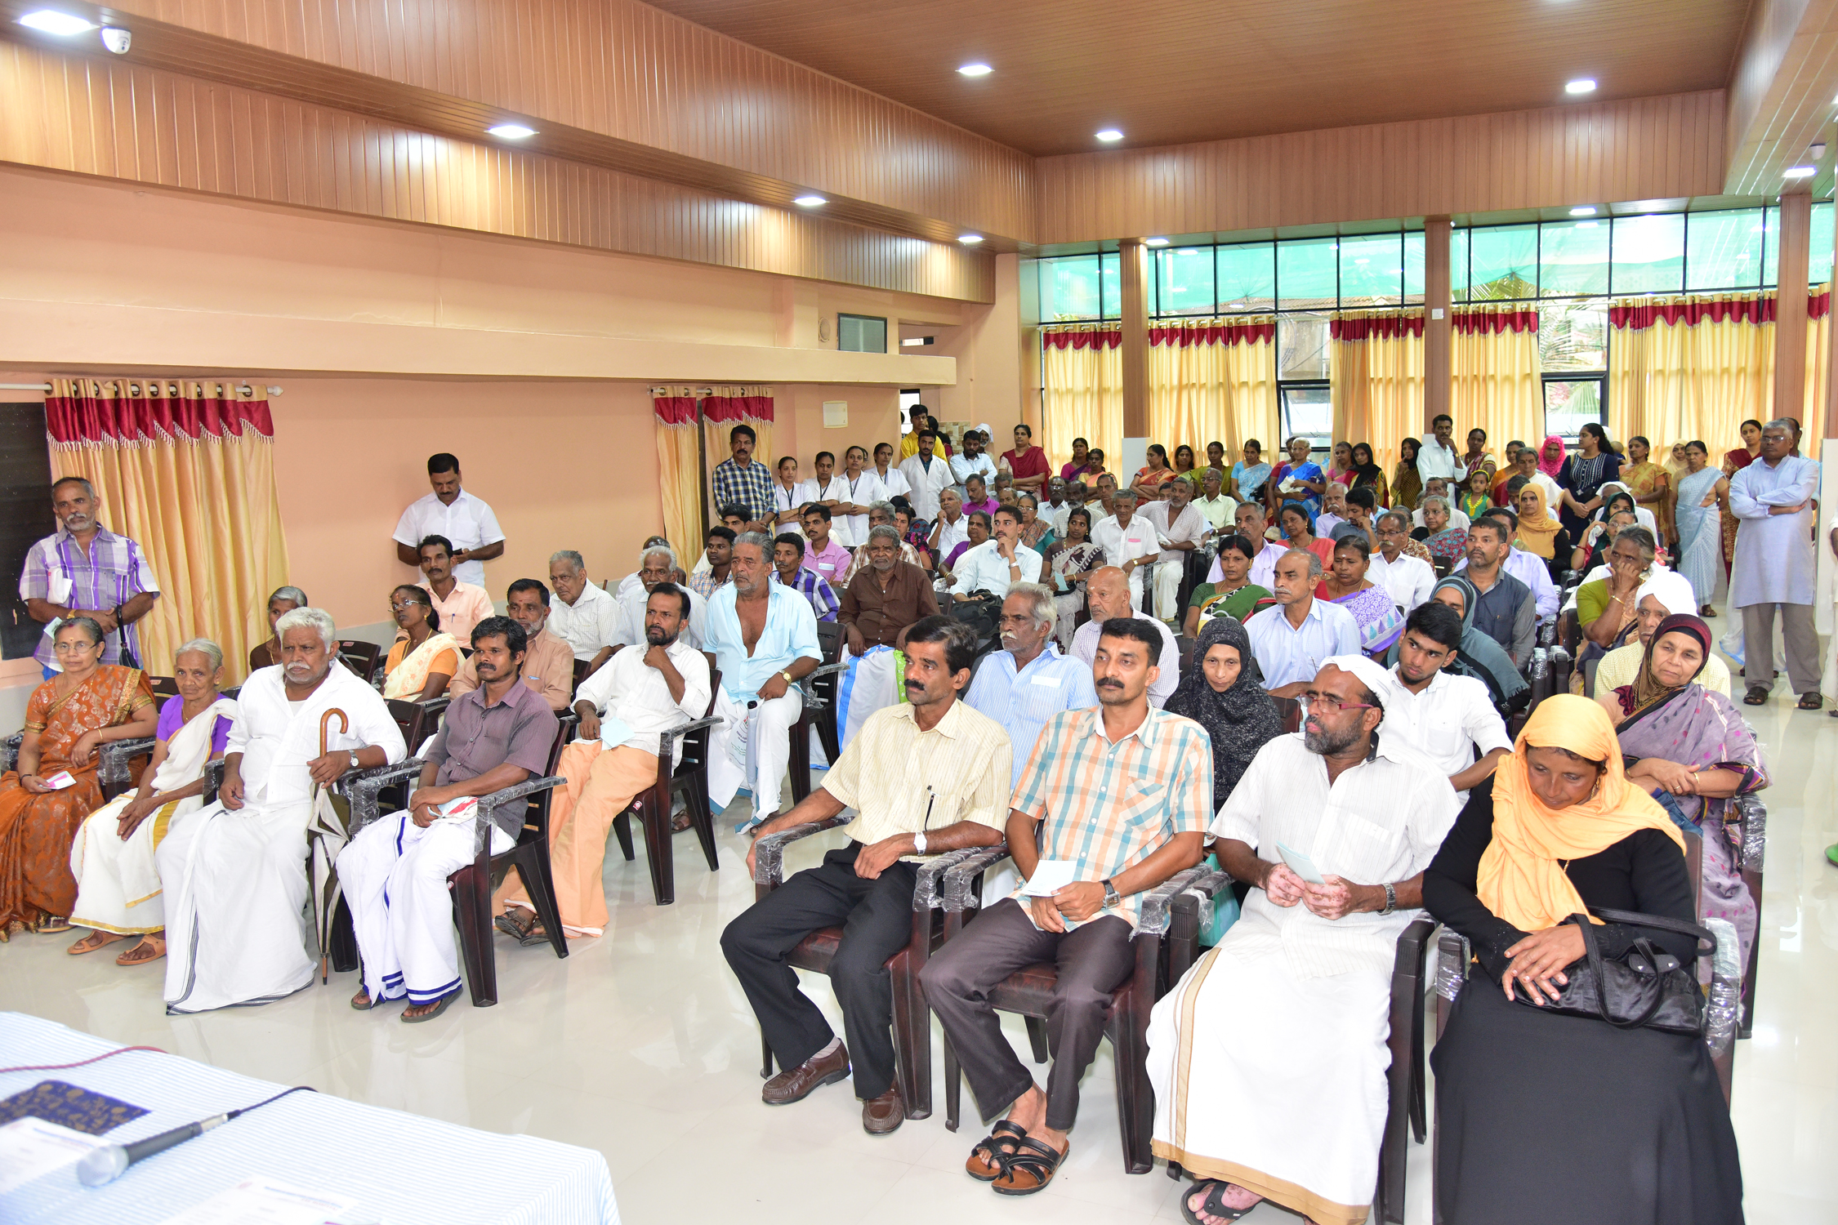

Participants of Nethrapakshacharana Samapana Sammelanam

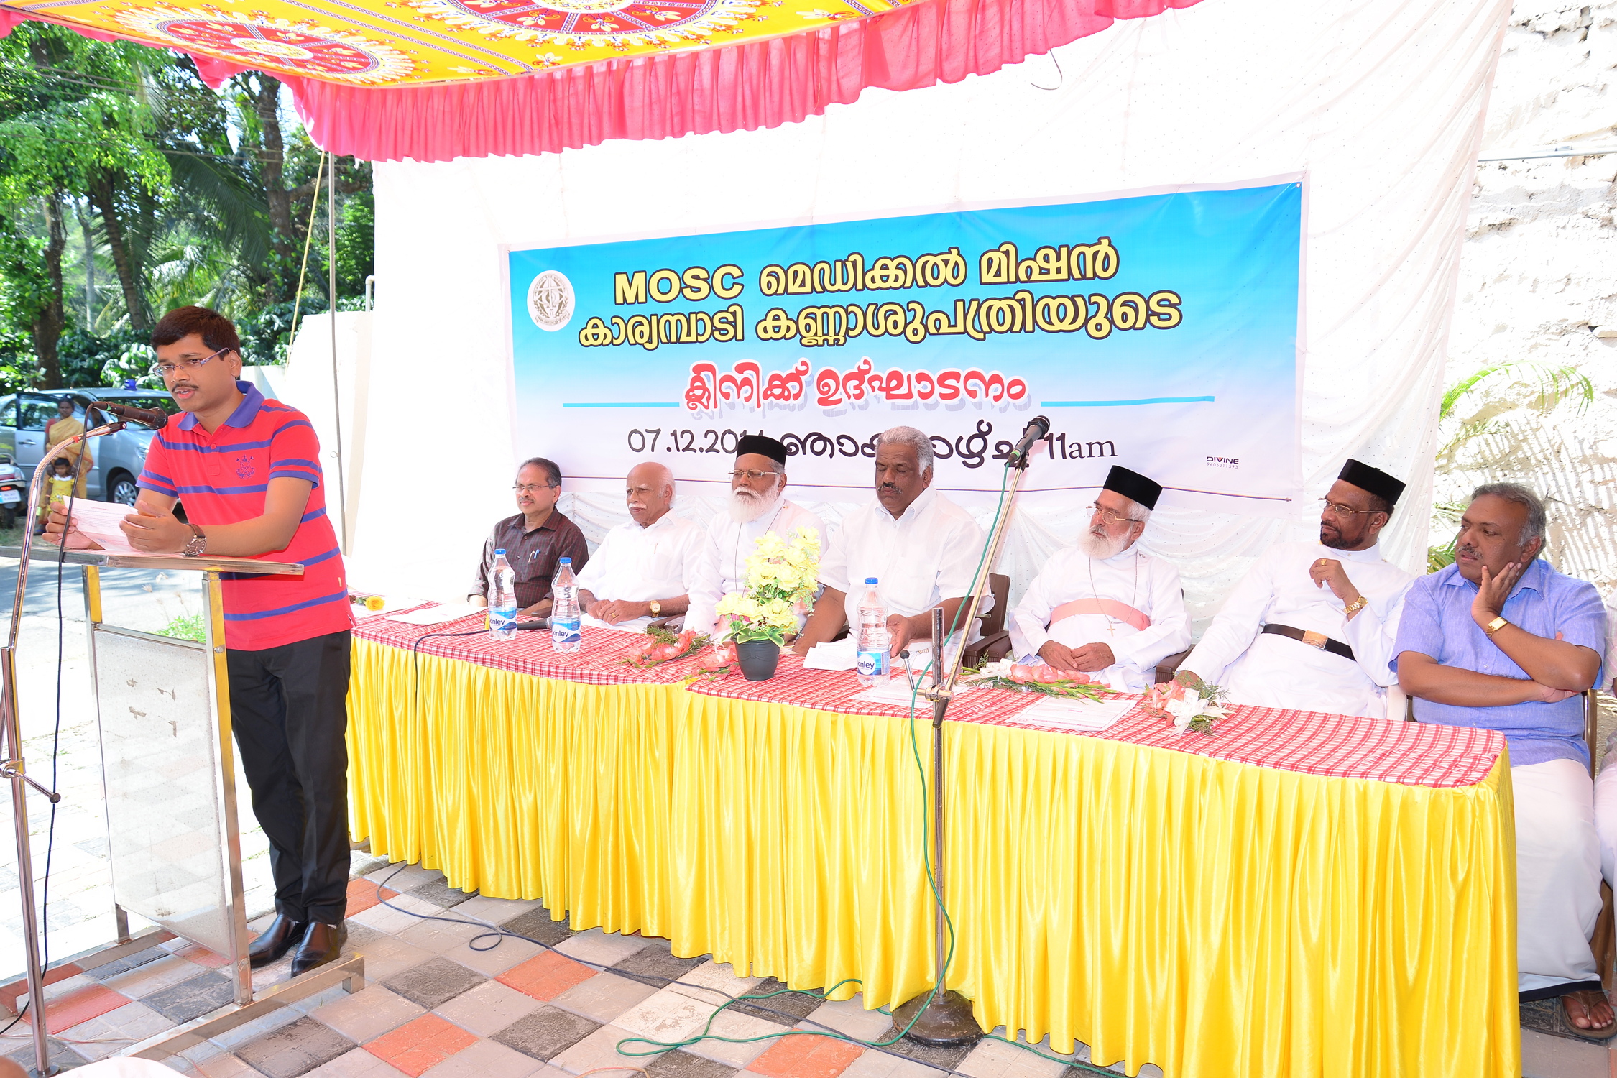

District Collector Mr.V.Kesevendrakumar I.A.S inaugurated the evening clinic

at district head quarters Kalpetta

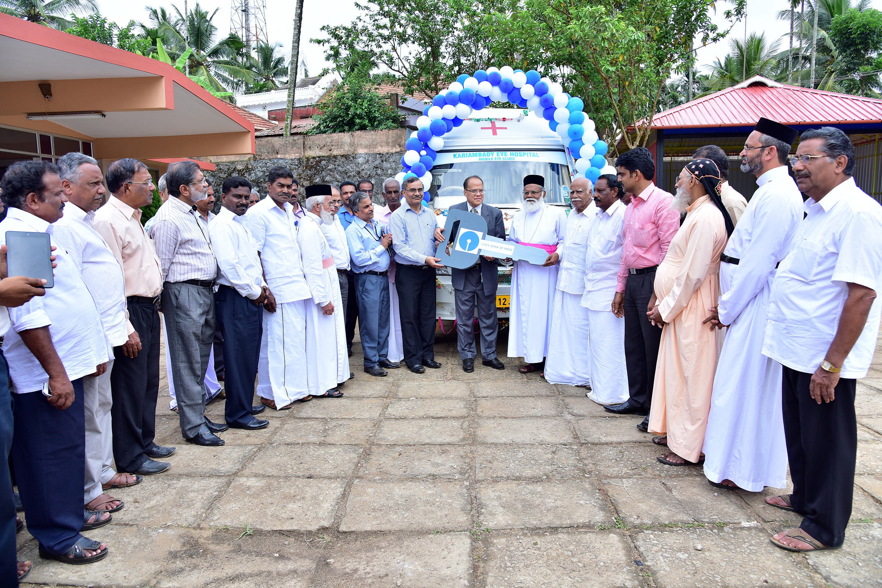

State Bank of India donated fully equipped Mobile Eye clinic unit

Inauguration ceremony. SBI General Manager Mr.Antonio Jose D’zoza hand over the key of fully equipped Mobile Eye clinic unit

Students free eye screening camp at SKMJ LP & UP School Kalpetta.

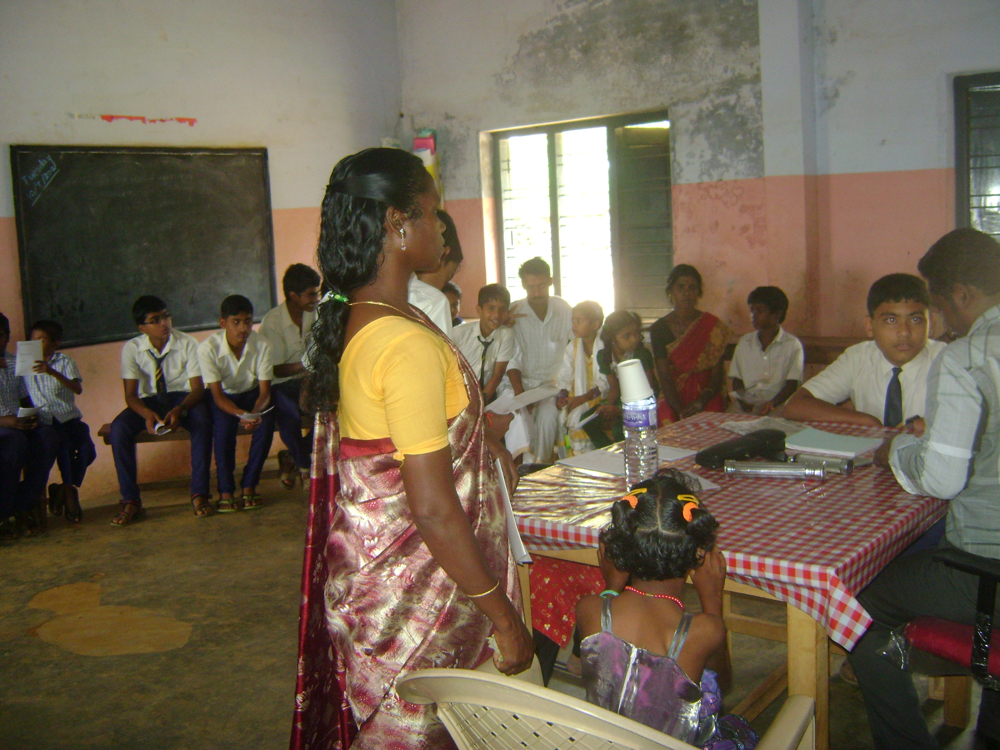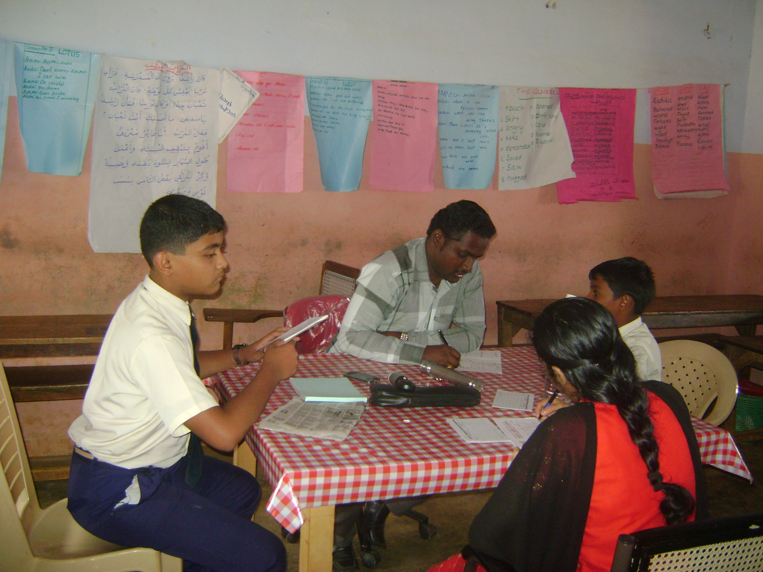

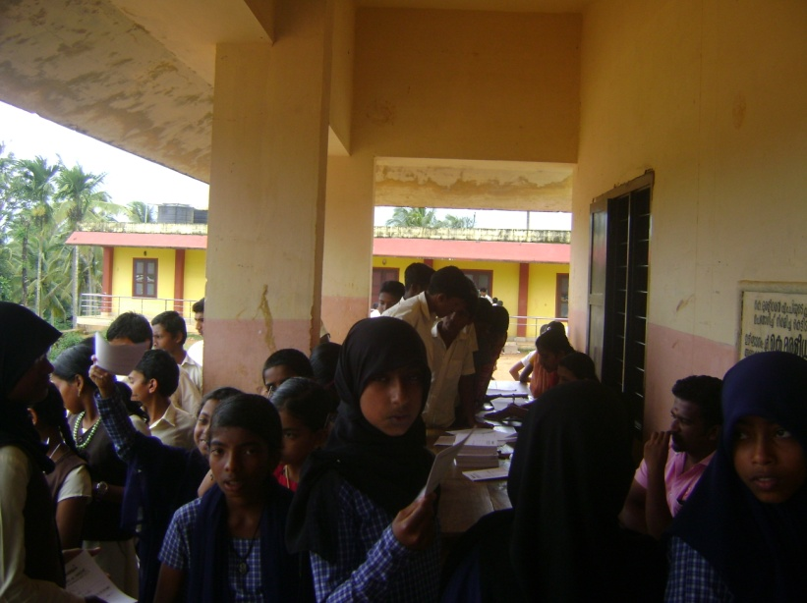

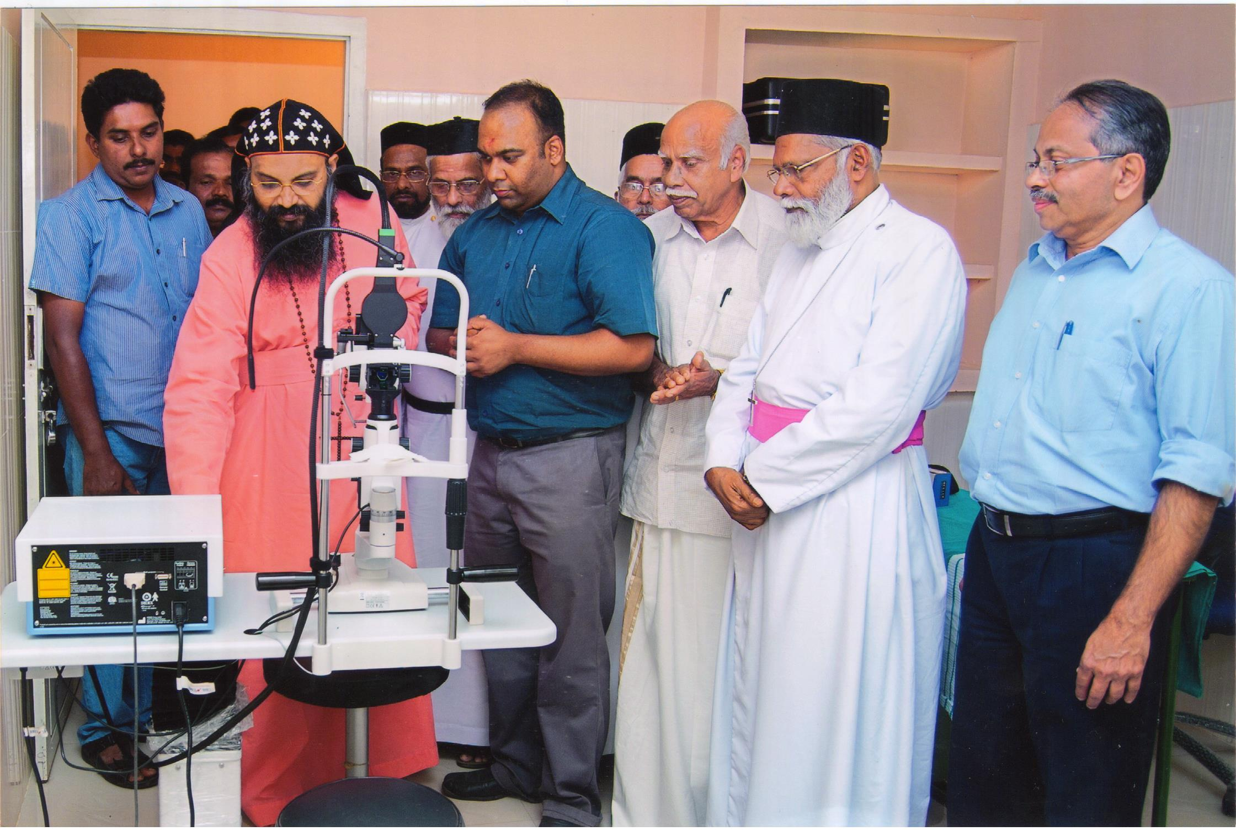

Installation ceremony of Diode Laser conducted by H.G.Dr.Abraham Mar Epiphanios Thirumeni

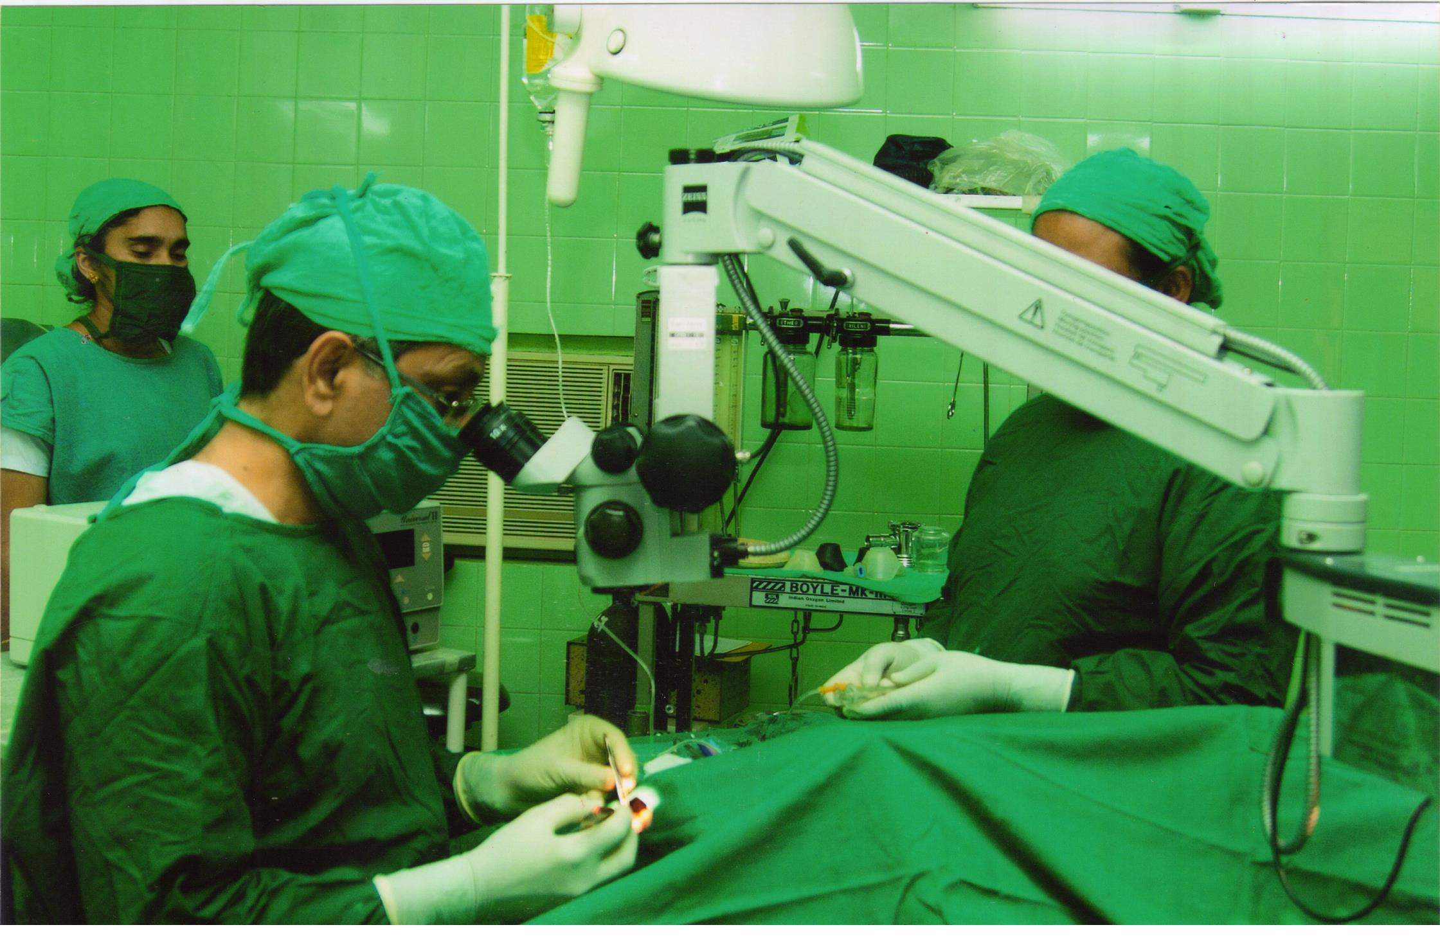

A view of Cataract IOL Surgery in Eye hospital AC operation theatre

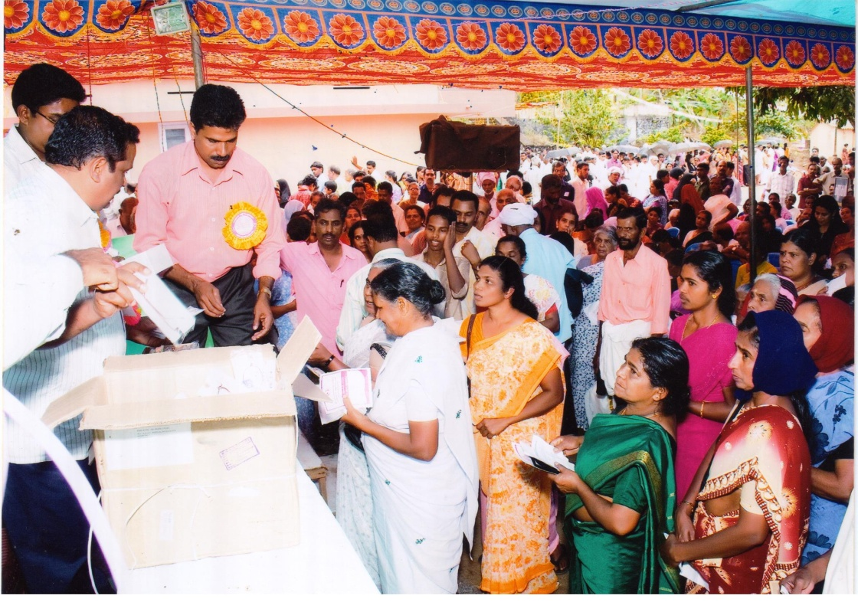

A view of 1000 free spectacle frames distribution in connection with Silver Jubilee Celebration

of MOSC Medical MIssion

**Our Patron & PresidentH.H.Bava Thirumeni with Vice President Epiphanios Thirumeni visit Kalpetta Evening clinic near Civil station Kalpetta.**

